Engine performance between 1000 and 2000

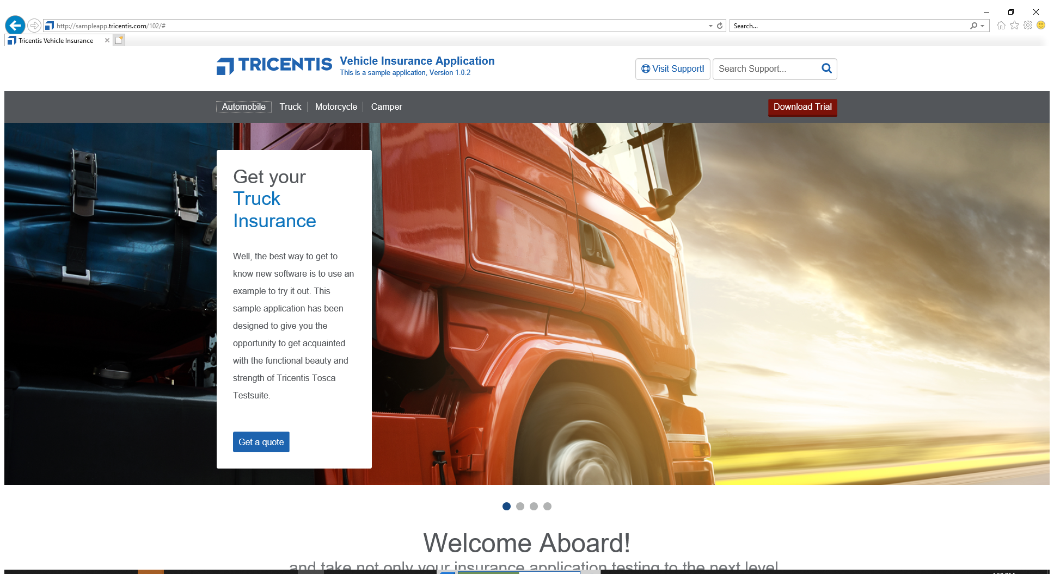 | Follow the link >Automobile<.
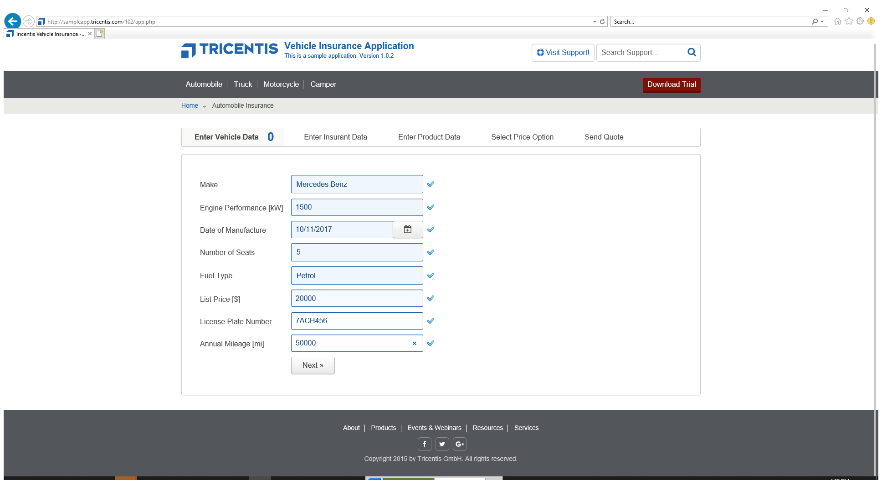 | Set >Make< to >Mercedes Benz<.  Set >Engine Performance [kW]< to >1500<.  Set >Date of Manufacture< to >10/11/2017<.  Set >Number of Seats< to >5<.  Set >Fuel Type< to >Petrol<.  Set >List Price< to >20000<.  Set >License Plate Number< to >7ACH456<.  Set >Annual Mileage< to >50000<.  Press button >Next »<.
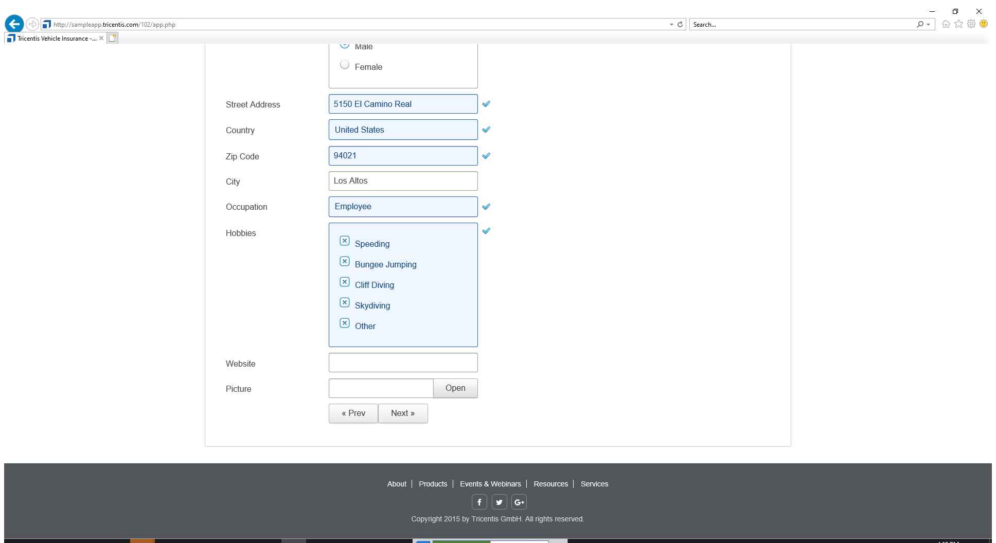 | Set >First Name< to >John<.  Set >Last Name< to >Doe<.  Set >Date of Birth< to >10/11/1994<.  Select radiobutton >Tricentis.Automation.AutomationInstructions.Dynamic.Values.StringValue<.  Set >Street Address< to >5150 El Camino Real<.  Set >Country< to >United States<.  Set >Zip Code< to >94021<.  Set >City< to >Los Altos<.  Set >Occupation< to >Employee<.  Check >Speeding<.  Check >BungeeJumping<.  Check >CliffDiving<.  Check >Skydiving<.  Check >Other<.  Press button >Next »<.
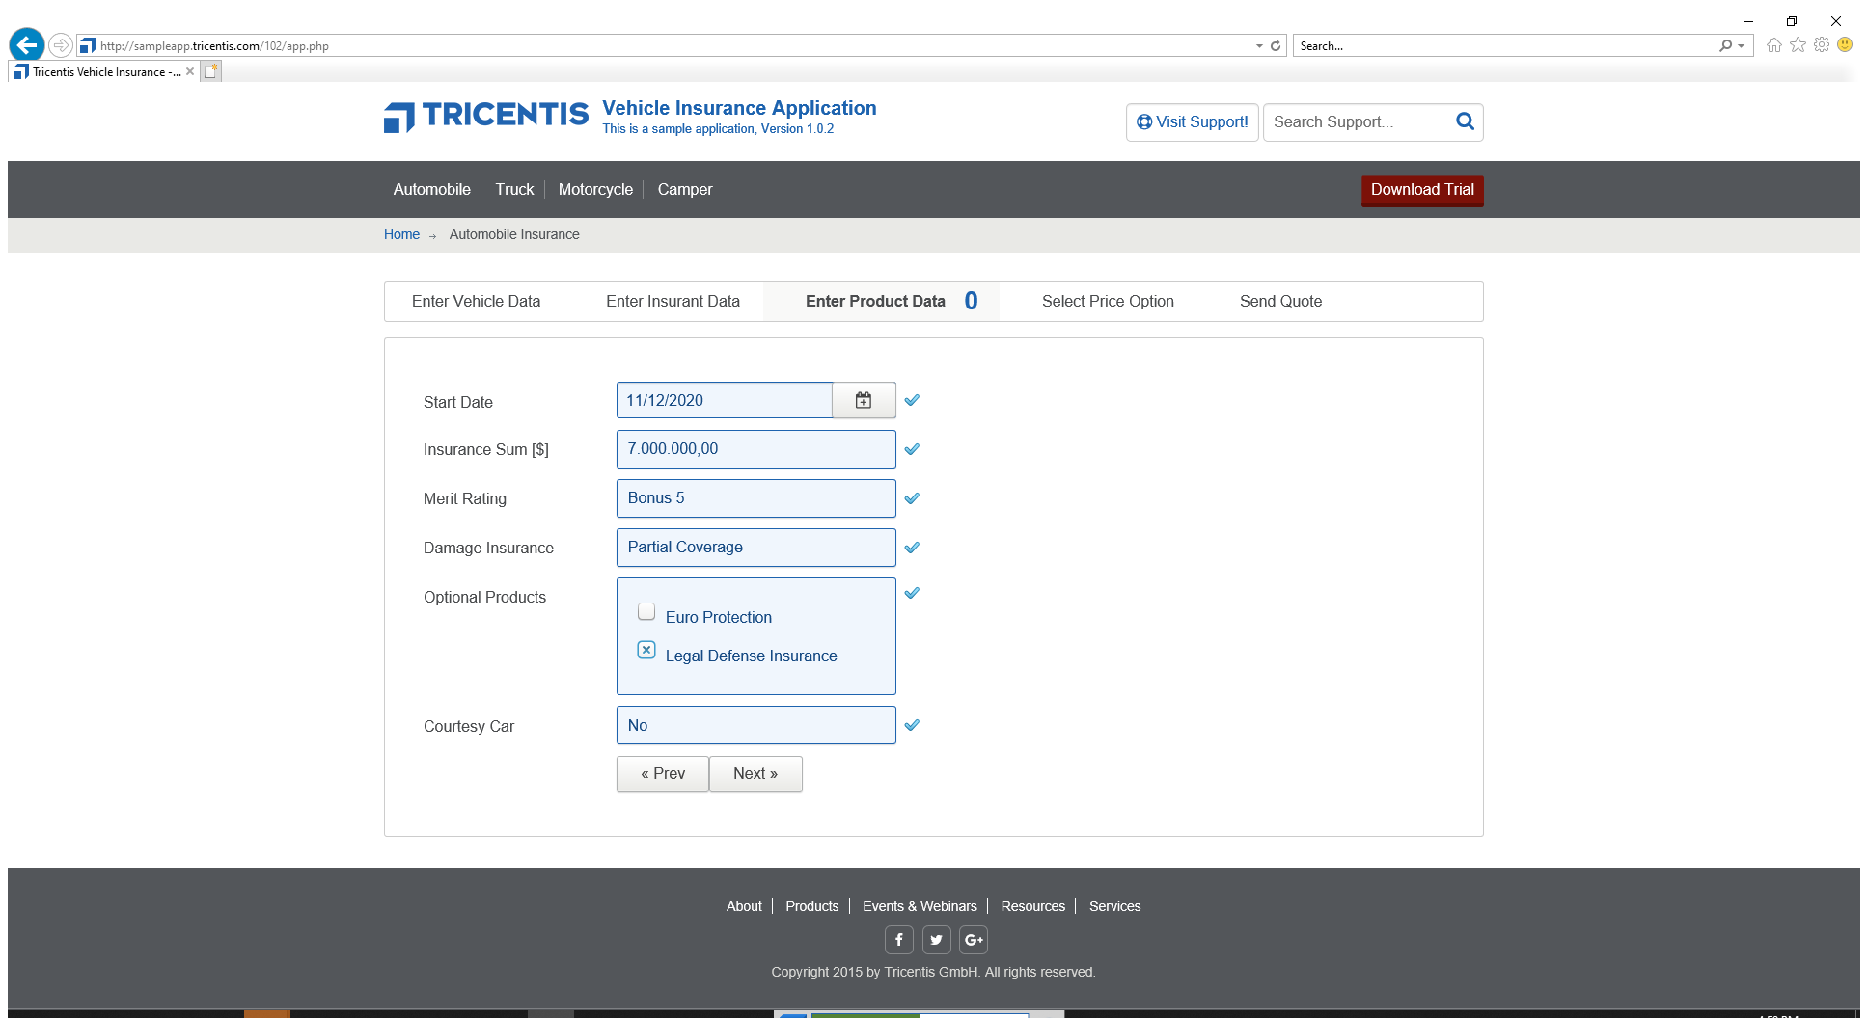 | Set >Start Date< to >11/12/2020<.  Set >Insurance Sum< to >7.000.000,00<.  Set >Merit Rating< to >Bonus 5<.  Set >Damage Insurance< to >Partial Coverage<.  Uncheck >Euro Protection<.  Check >Legal Defense Insurance<.  Set >Courtesy Car< to >No<.  Press button >Next »<.
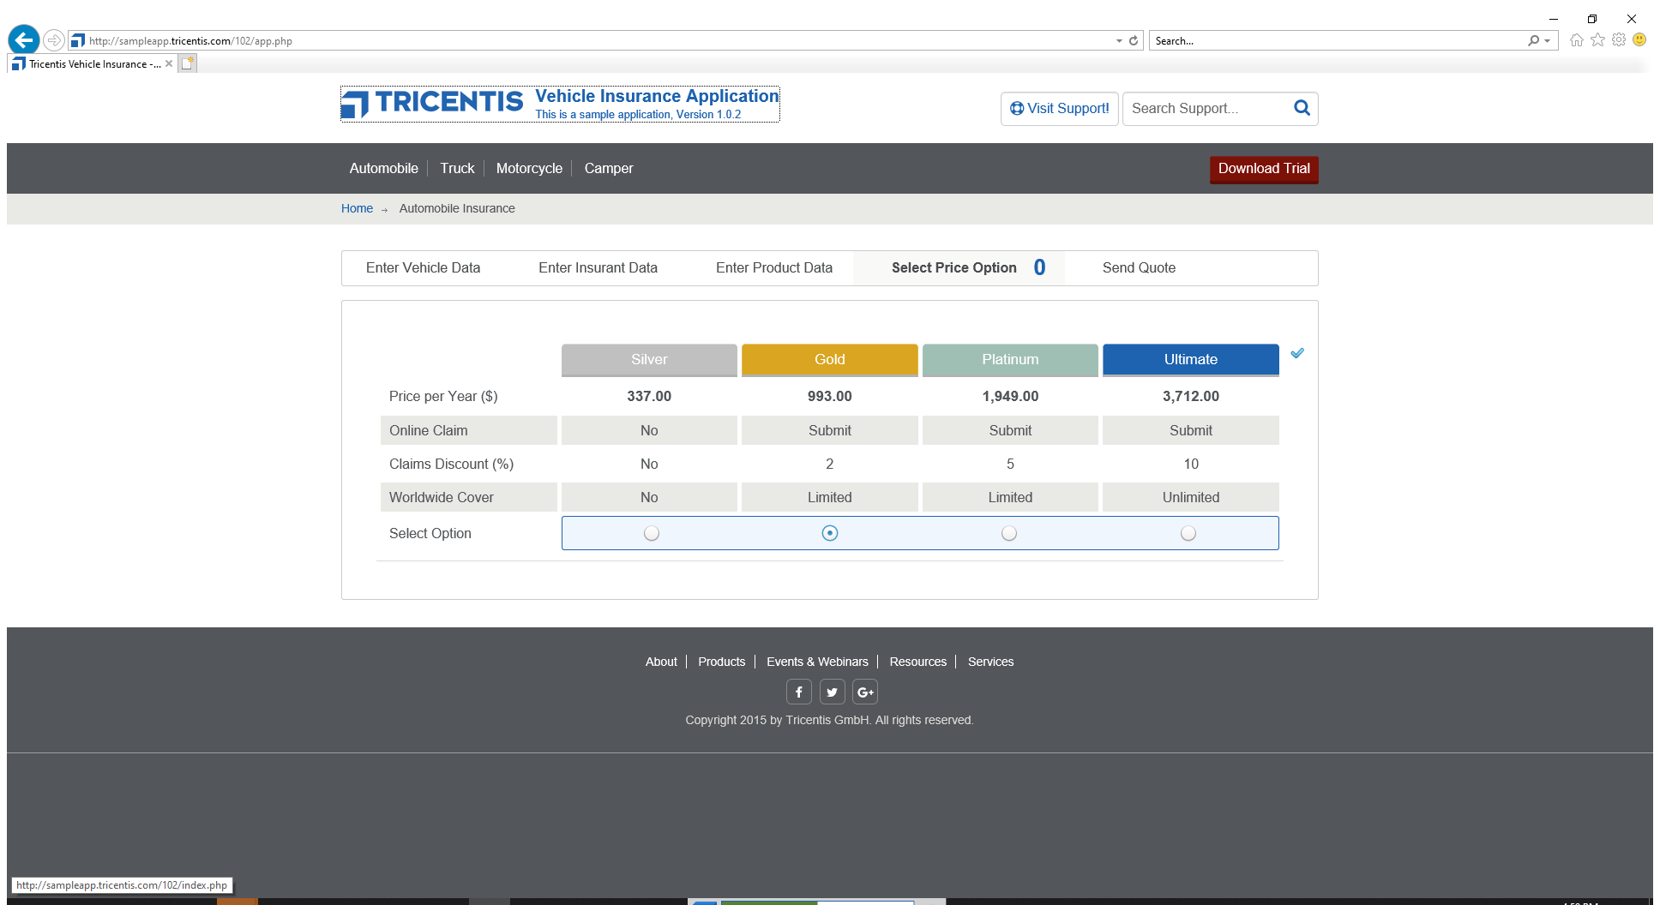 | Verify if the value of the cell in row >Price per Year ($)< and column >Silver< is >337.00<.  Verify if the value of the cell in row >Price per Year ($)< and column >Gold< is >993.00<.  Verify if the value of the cell in row >Price per Year ($)< and column >Platinum< is >1,949.00<.  Verify if the value of the cell in row >Price per Year ($)< and column >Ultimate< is >3,712.00<.  Select radiobutton >Tricentis.Automation.AutomationInstructions.Dynamic.Values.StringValue<.  Follow the link >Home<.

